Solved the i2c hang problem.

1. I must clear the NACK flag manually in software when NACK is set during the reset operation for gyro IC.
2. I must send a STOP signal to make master release both SDA and SCL lines, so that subsequent i2c operations can be performed without hanging in any “complete flag” monitoring while loops.

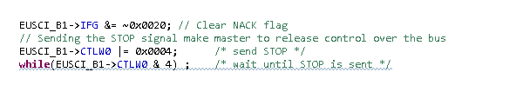

Rewritten algorithm to perform reset during the initial configuration procedure for gyroscope IC(FXAS21002C) :

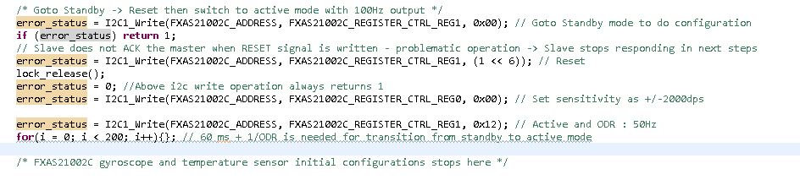

REFERENCE :

1. MS432 Technical reference manual page 432 (i2c transmitter mode).
   1. <https://www.ti.com/product/MSP432P401R>
2. About NACK signal during reset operation in gyroscope IC(FXAS21002C) :
   1. <https://cdn-learn.adafruit.com/assets/assets/000/040/671/original/FXAS21002.pdf?1491475056>

(Page 46)